**Student Id:** 21110214.

**Submitted to:** Batool Al Armouti.

**Submitted by:** Saif Kamal Salim Haddad.

**Submitted on:** 9-6-2024.

**Course number:** 30202251.

Artificial Intelligence:

**Technical Report.**

**Table of Contents**

***Part (1) Introduction: 3***

**Q1:** 3

**Q2:** 7

**Q3:** 10

***Part (2) Bottom-up Approach: 11***

**Q1:** 11

**Q2:** 13

**Q3:** 14

**Q4:** 15

**Q5:** 21

**Q6:** 23

**Q7:** 25

***Part (3) Top-down Approach: 26***

**Q1:** 26

**Q2:** 28

**Q3:** 29

**Q4:** 30

**Q5:** 32

***Part (4) Emerging Technologies: 33***

**Q1:** 33

**Q2:** 34

**Q3:** 35

**Q4:** 35

***References: 36***

**Part (1)** **References:** 36

**Q1:** 36

**Q2:** 36

**Q3:** 37

**Part (2) References:** 37

**Q1:** 37

**Q6:** 38

**Q7:** 38

**Part (3) References:** 38

**Q1:** 38

**Q4:** 39

**Q5:** 39

**Part (4) References:** 40

**Q1:** 40

**Q2:** 40

## **Q1:**

* **General Overview:**

A lot of industries have been transformed because of the use of Artificial Intelligence which has the ability to automate processes, analyze huge amounts of data, and learn from results. The AI has the power to completely change and transform the healthcare sector by improving the accuracy, efficiency, and uniqueness of patient monitoring, diagnostic, and treatment processes.

* **Artificial Intelligence Fundamentals and Philosophical Issues:**
  + **Fundamentals of AI:**

The base of AI is the study of the computations and mathematics that are needed for understanding and clarifying things, also for giving reasons and taking action. AI involves creating systems (development of algorithms and computational programs), and these systems can carry out operations that usually need human intelligence and the human brain. These contain systems such as solving problems, identifying patterns, making conclusions, finding patterns and learning from data, and making decisions. (Author et al., 2024)

* + - **Core Components of AI:**
      * **Learning:**

It learns over time by analyzing historical data using the AI system. Machine Learning is a part of artificial intelligence which gives the power to get access to data and make fast decision by itself and further not depend on be specified programming and also not on be human. (Laskowski & Tucci, 2024)

* + - * **Reasoning:**

This means that the AI have the ability to work on data and make decisions based on what the AI learned and also based on logic. (Laskowski & Tucci, 2024)

* + - * **Perception:**

AI systems have the ability to understand the surrounding environment because Ai has multiple functions such as image recognition, text recognition, and voice recognition. (Laskowski & Tucci, 2024)

* + - * **Self-correction:**

Artificial intelligence (AI) systems have the ability to improve and fix their algorithms every time and also Ai uses human feedback to improve the accuracy. (Laskowski & Tucci, 2024)

* + **Philosophical Issues:**
    - **In the healthcare sector:**
      * **Ethical AI Use:**

AI usage in the healthcare domain should be cautious, because results can be instances of skew in responsibilities as regards patient privacy and leave. (NuAIg. ai, 2020)

* + - * **Trust and Transparency:**

Other than that it is a well-known fact that all AI systems are black boxes and do not reveal the way that how the system came to a decision which then results in some issue of trust among patients on using these systems.

(NuAIg.ai, 2020)

* + - * **Moral and Social Implications:**

Using artificial intelligence in healthcare begs the question of replacing people with machines and the ethical considerations related to robots deciding on life and death. (NuAIg. ai, 2020)

* + - **In general:**
      * **Intentionality and Consciousness:**

The most fundamental question is whether AI could have true consciousness or intentions when philosophers such as John Searle insist that machines can be designed to simulate human behavior, but cannot acquire real knowledge. (NuAIg. ai, 2020)

* + - * **Limits of Machine Intelligence:**

The power of artificial intelligence to truly reproduce human thought is curbed by issues with implicit understanding, by which I mean things that everyone understands, but hard to show or express. (NuAIg. ai, 2020)

* + - * **Ethics and Safety:**

In domains where AI is increasingly integrated, such as autonomous weapons or biased decision-making systems, questions of ethical behavior and potential harm become issues of high concern. (NuAIg. ai, 2020)

* + - * **AI and Human Identity:**

Artificial intelligence (AI) questions the standing beliefs humanity has about how to be unique that are tied up in being creative and emotional characteristics that computers may not imitate completely. (NuAIg.ai, 2020)

* + - * **Transparency and Trust ("Black Box" Problem):**

When AI’s decision-making processes are unexplained, trust issues can arise especially where outcomes have serious implications. (NuAIg.ai, 2020)

* + **Types and Areas of Application**
* **Common Applications of AI:**

1. **finance:**

AI makes a difference with things like following calculations, spotting extortion, and recognizing unordinary client behavior.

1. **Retail:**

In retail, AI makes personalized suggestions to make strides the client encounter, oversees stock inventively, and robotizes checkouts.

1. **Manufacturing:**

Artificial Intelligence estimates maintenance needs and associated costs, improves quality assurance, and streamlines the supply chain.

1. **Transportation:**

AI advances GPS frameworks and helps autonomous vehicles navigate traffic and choose the best routes.

* **Types of AI Used in Healthcare Applications:**
  + - * **Artificial Narrow Intelligence (ANI):**

The primary use of ANI is in the healthcare sector, where it succeeds in tasks like patient data management, continuous essential monitoring, and medical picture analysis. (Author et al., 2024) (Zellers & Talingting, 2023)

* + - * **Artificial General Intelligence (AGI):**

has the ability to understand, learn, and apply knowledge across a broad range of tasks.

By replicating a human doctor's understanding and reasoning abilities with medical data and patient histories, artificial intelligence (AGI) may be able to deliver complete treatment at scale like a doctor. (Author et al., 2024) (Zellers & Talingting, 2023)

* + - * **Artificial Super-Intelligence (ASI):**

The possibility that ASI is more intelligent than humans could transform medical research and result in the independent development of treatments. (Author et al., 2024) (Zellers & Talingting, 2023)

* + - **Detailed Applications of AI in Healthcare:**
      * **Disease Diagnosis and Treatment:**
        + **Machine Learning and Computer Vision:**

To diagnose illnesses faster and more accurately than ever before. AI can be used to analyse MRIs, CT scans and X-rays to detect cancers for example.

(Author et al., 2024) (Zellers & Talingting, 2023)

* + - * + **Example:**

To increase the precision and speed of cancer diagnosis, AI-driven diagnostic technologies have become widely employed in pathology and radiology. (Author et al., 2024) (Zellers & Talingting, 2023)

* + - * **Personalized Medicine:**
        + **Machine Learning:** AI enhances the effectiveness of treatments by customizing treatments for each patient based on lifestyle and genetic data. (Author et al., 2024) (Zellers & Talingting, 2023)
        + **Example:**

AI is used by oncology departments to customize cancer treatment regimens that take into consideration the genetic composition of the tumor and the patient, increasing the probability of successful outcomes. (Author et al., 2024) (Zellers & Talingting, 2023)

* + - * **Operational Efficiency:**
        + **Robotics and NLP:**

AI improves hospital operations by automating repetitive processes like scheduling, managing patient data, and even providing direct patient care via robotic nursing assistants. (Author et al., 2024) (Zellers & Talingting, 2023)

* + - * + **Example:**

Hospitals use robots to carry supplies and medications, and AI systems to schedule personnel and patients, cutting down on wait times and costs. (Author et al., 2024) (Zellers & Talingting, 2023)

* + - * **Patient Monitoring and Care:**
        + **Machine Learning:**

Patients with chronic diseases or those recovering from surgery are continuously monitored, giving doctors and nurses access to real-time data. (Author et al., 2024) (Zellers & Talingting, 2023)

* + - * + **Example:**

Wearable technology monitors vital indicators such as heart rate, blood sugar, and other parameters, facilitating early detection of problems and active condition treatment. (Author et al., 2024) (Zellers & Talingting, 2023)

## **Q2:**

* **General Overview:**

Artificial intelligence (AI) has significantly changed our everyday lives over the last 20 years, offering numerous wonderful benefits and difficult challenges. It has changed important industries by incorporating intelligent systems into a range of domains. (Ideta, 2022)

* **Evolution of AI:**

The shift started in the late 1990s and early 2000s, this happened when machine learning and other processing pushed artificial intelligence (AI) from theoretical and experimental phases to real-world applications, this period was the beginning of using AI for diagnostics, and management of healthcare data. (Ideta, 2022)

* **Impact of AI:**
  + **Security:**

The security environment has been significantly increased by the increasing integration of AI across multiple fields especially in healthcare. AI-driven systems improve security procedures in healthcare systems, but they also bring new risks and difficulties that must be carefully handled in healthcare. (terranovasecurity, 2022)

* + - **Strength Introduced by AI:**
      * **Enhanced Detection and Response:**

AI technologies have completely changed how threat factors in healthcare are identified and dealing with. These systems can quickly detect irregularities and possible threats, including unusual network traffic or illegal access attempts through using machine learning and data analytics. This will lead the business to quicker handle any attack that is done by hackers on the privet information of patients in healthcare sector. (terranovasecurity, 2022)

* + - * **Automation and Efficiency:**

AI has decreased the likelihood of human errors and increased the overall operational efficiency of security by taking over a number of functions, such as threat detection, response procedures, and system impairment, in healthcare. IT employees now can focus on more important tasks such as complicated threats and leave other simple tasks for AI, Which can benefit the healthcare clinic or hospital by hiring low numbers of IT employees and saving money. (terranovasecurity, 2022).

* + - **Issues and challenges that might happen by AI:**

AI does not all the time enhance security, using and applying AI could lead to big problems in security: (terranovasecurity, 2022)

* + - * **Privacy and Compliance Issues:**

In the healthcare sector, they use Ai to process a large number of patients’ data. Ensuring that these systems meet international privacy laws and regulations is an important problem that is hard to control and also it requires robust security measures that are costly to protect patients’ data from theft in data processing. (terranovasecurity, 2022)

* + - * **Cyber Attacks that are done by AI:**

AI helps with protecting patient information in healthcare sectors, but it also gives attackers more advanced tools. With AI, cyber criminals may be automated and improve the effectiveness of their activities, producing malware that is more flexible and targeted and able to carry out large-scale attacks with more accuracy on patient’s private information. (terranovasecurity, 2022)

* + - * **Data damaging and Editing Information:**

If patient data is altered, corrupted, or manipulated, the AI's findings might be biased. This might result in inaccurate risk assessments and security breaches, which could seriously impair treatment plans.2022)

* + **Ethical issues**:

Ai usage can be useful but it produces higher ethnical problems majorly in the healthcare sector. (World Economic Forum, 2022)

* + - **Issues and challenges Introduced by AI:**
      * **Bias and Unfair Outputs:**

If artificial intelligence (AI) develops flaws from algorithm design or training data, it may yield biased outcomes in important healthcare domains. This may result in erroneous diagnoses and patient treatment priority, which would lower patient satisfaction and undermine public confidence in medical institutions. (World Economic Forum, 2022)

AI can produce biased results due to flaws in algorithm design or training data, leading to incorrect diagnoses and treatment priorities, which undermines patient trust and satisfaction.

* + - * **Privacy Concerns:**

AI systems have the potential to violate people's privacy, especially those that handle medical data and large-scale data analytics..

* + - * **Can not be controlled and does not take permission :**

Lack of Control and Consent: The potential for AI to act on behalf of patients or make choices presents important questions about patient autonomy and the need for informed consent in the medical field. Patients may lose control over their health decisions or endure unwarranted operations as a result (World Economic Forum, 2022). (World Economic Forum, 2022)

* + - * **Job Displacement and Economic Impact:**

Because AI automation is applied this leads to employment displacement in the healthcare sector because AI automates more work and achieves tasks than humans. (World Economic Forum, 2022)

* + **Social Issues:**.

The main cause of social issues is the use of AI tools and applications in the health sector and other major sectors (Tai, 2020) (qualcomm, 2022) (Krasadakis, 2023) (Joanna J. Bryson University of Bath et al., 2022)

* + - * **Job Displacement and Unemployment:**

Using AI in the healthcare sector will definitely cause job losses for employees. AI-driven diagnostic tools and administrative bots can reduce the need for some roles in healthcare, affecting problems for people to find jobs in these sectors. (Tai, 2020) (qualcomm, 2022) (Krasadakis, 2023) (Joanna J. Bryson University of Bath et al., 2022)

* + - * **Economic Inequality:**

Artificial intelligence advancements have the potential to increase the wealth gap by benefiting its investors significantly in the healthcare sector, Because advanced AI technologies are costly, only well-funded healthcare providers may be able to purchase them, which might expand the gap between healthcare services in rich and poor locations. (Tai, 2020) (qualcomm, 2022) (Krasadakis, 2023) (Joanna J. Bryson University of Bath et al., 2022)

* + - * **Loss of Human Interaction:**

AI tools like telemedicine and automated patient management have the ability to reduce human interaction face to face and change social relationships in the healthcare sector by taking over tasks that would have needed in-person meetings and also affect the patient-provider relationship which leads to issues in patient satisfaction and trust which was there before ai. (Tai, 2020) (qualcomm, 2022) (Krasadakis, 2023) (Joanna J. Bryson University of Bath et al., 2022)

* + - * **Threat to Human Autonomy:**

The fear that AI will surpass human intelligence and capabilities is a significant problem, particularly in the field of healthcare. As a result, there are situations where AI defies the creators' intentions. (Tai, 2020) (qualcomm, 2022) (Krasadakis, 2023) (Joanna J. Bryson University of Bath et al., 2022)

* + - * **Losing Control of AI:**

If AI tools are not managed properly this will give Ai tools the ability to work without doctors’ permission AI is not fully understood or controllable by human operators which leads to some errors and ethical damage in patient care. or (Tai, 2020) (qualcomm, 2022) (Krasadakis, 2023) (Joanna J. Bryson University of Bath et al., 2022)

## **Q3:**

* **Overview:**

Artificial Intelligence (AI) is changing a variety of individual lives and how society is structured while providing innovative solutions and advancements in a range of fields.

* **Some of the contributions that AI had to individuals and society:**
  + - **Climate Change Research:**

AI-driven models can management of climate effects and optimize the carbon footprint by merging the Geospatial AI that is used in both IBM and NASA to forecast crop yields and monitor natural disasters (Marr, 2024) (Writer, 2023)

* + - **Precision farming and the restoration of coral reefs:**

Artificial Intelligence helps with the restoration of coral reefs and enhancing agricultural practices. This could be done by precision farming techniques that lower the usage of pesticides and boost up crop yields. (Marr, 2024) (Writer, 2023)

* + - **Enhancing Human Creativity:**

Filmmakers may now show fast creations of scripts, artwork, and music with the help of AI. AI-powered video editing software is only one great example for how technology and AI can help with the publishing and the creating process as individuals. (Marr, 2024) (Writer, 2023)

* + - **Automating Routine Tasks:**

Artificial intelligence (AI)-enabled equipment, for example John Deere tractors, can perform various farming tasks independently, which increases the output and makes remote administration possible. (Marr, 2024) (Writer, 2023)

* + - **Enhancing Decision-Making:**

AI-driven analytics, already employed in cities like Singapore, Los Angeles, and Barcelona helps a lot in improves traffic management and safety in metropolitan settings through data-driven and decision-making.. (Marr, 2024) (Writer, 2023)

# **Part (2) Bottom-up Approach:**

## **Q1:**

* **Bottom-Up Approaches:**

In artificial intelligence, the bottom-up approach begins with small, detailed components or procedures and integrates them into higher-level characteristics. This approach depends on learning from data or specific instances which enables the system to build more complex structures and functions based on the fundamental components. (Simplilearn, 2024) (Staging TD, 2024)

* + **Techniques in Bottom-Up Approaches:**
    - **Swarm Intelligence:**

It is a complex field of research that looks at artificial and natural systems having several parts that function effectively together because of centralized management. Common instances of this type of intelligence in the natural world are the actions of fish, ants, birds, and bees. Therefore, the collective behavior that results from social insects cooperating and according to a few norms might be thought of as swarm intelligence. The collective activity that arises in systems with locally interacting elements is known as swarm intelligence. (Simplilearn, 2024) (researchgate, 2022)

* + - * **Advantages**:

Simplifies intricate logistics and handling of resources.

Capable of responding to adjustments in the surrounding  environment.

* + - * **Disadvantages**:
* Make extensive use of computation
* Underperform on really difficult and complicated jobs
  + - **Machine Learning Techniques:**

Machine learning algorithms use data to learn from and predict the future.

After gathering data from the healthcare industry, AI may build models that enable it to recognize patient ailments and provide therapy accordingly. (Simplilearn, 2024) (researchgate, 2022)

* **Advantages**: (DataFlair, 2024)
  + accurate predictions
  + Can collect, handle, and analyze large data.
* **Disadvantages** (DataFlair, 2024)
  + Needs a huge amount of data for effective training.

Biased results occasionally if the training data is not balanced or reflective of

* + - **Data-Driven Techniques:**
      * **Deep Learning:**

This technique uses layered neural networks to interpret data at many levels of abstraction. This method works particularly well for handling massive amounts of complicated data, such as text, audio, and picture files. (Simplilearn, 2024) (researchgate, 2022)

* + - * + **Advantages** (GeeksforGeeks, 2023)

Can process complex images, sounds, and text that are entered as data.

* + - * + **Disadvantages**: (GeeksforGeeks, 2023)

black-box nature no one can know how the design was made

* + - **Natural Language Processing Techniques:**
      * **Tokenization and Parsing:**

These basic approaches involve breaking down the text into words, sentences, or other noteworthy elements (tokens), and then examining the output to determine the grammatical structure. (Simplilearn, 2024) (researchgate, 2022)

* + - * + **Advantages:** (JohannesJohannes 33633 silver badges99 bronze badges et al., 1960)

Break down text into parts that are easier to manage for the analysis.

Helps in understanding the grammatical structure of the text.

* + - * + **Disadvantages:** (JohannesJohannes 33633 silver badges99 bronze badges et al., 1960)

Hard to analyze poorly structured text

Hard to deal with text with multiple languages.

* + - * **Sentiment Analysis:**

Using this technique figure out whether the sentiment if it is positive, neutral, or negative which is shown in a text (researchgate, 2022)

* + - * + **Advantages:** (JohannesJohannes 33633 silver badges99 bronze badges et al., 1960)

Can quickly classify the sentiment.

Useful for analyzing customer feedback and opinions.

* + - * + **Disadvantages:** (JohannesJohannes 33633 silver badges99 bronze badges et al., 1960)

The accuracy depends a lot on the quality of the training data.

* **Neural Networks:**

Are artificial intelligence (AI) models which take ideas from the human brain and are built to identify patterns and make choices by analyzing feedback through network layers of neurons. For tasks like recognizing images, natural language processing, and predictive analytics, they are extensively utilized.

* + **Tools for Putting Bottom-Up Methods into Practice:**
    - **Machine Learning Tools:** 
      * **Azure Machine Learning:**
        + **Advantages:** (Singh, 2018)

Cloud-based that have a lot of services on it

It is automated and does all the work by itself

* + - * + **Disadvantages:** (Singh, 2018)

Expensive to buy a subscription.

Not everyone knows how to use it

* + - * **Scikit-learn:** A simple and efficient tool for data mining and data analysis built on NumPy, SciPy, and matplotlib (Mudadla, 2023)
        + **Advantages:** (upGrad blog, 2023)

User-friendly and easy to use especially for beginners.

Use simple language which is Python.

* + - * + **Disadvantages:** (upGrad blog, 2023)

Do not have the ability to do deep learning

Have issues to deal with huge data sets

* + - **Deep Learning Tools:**
      * **Keras:** A high-level neural networks API, written in Python and capable of running on top of TensorFlow, CNTK, or Theano (Mudadla, 2023)
        + **Advantages:** (DataFlair, 2021)

High usability because can run multiple application in the back end together

Easy to make and build deep learning models using it

* + - * + **Disadvantages:** (DataFlair, 2021)

Have low-level libraries not advance

Needs a lot of time to run big data sets.

* + - **Natural Language Processing Tools:**
      * **NLTK (Natural Language Toolkit**): A leading platform for building Python programs to work with human language data (Mudadla, 2023)
        + **Advantages:** (linkedin, 2022)

One of the best for cases of students and simple tasks.

* + - * + **Disadvantages** (linkedin, 2022)

Very slow because the libraries is out of date

* + **Advantages of Bottom-Up Approaches**
    - **Incremental Complexity:**

These techniques make it possible to create systems that can be basic at first, but as they process more data they may slowly grow more complex. (Simplilearn, 2024) (Staging TD, 2024)

* + - **Innovation in Problem-Solving:**

Innovative solutions to issues that might not be clearly defined or are too complicated for traditional top-down methods can be found using techniques like deep learning and algorithmic evolution. (Simplilearn, 2024) (Staging TD, 2024)

* + - **Flexibility and Adaptability:**

Bottom-up techniques make it possible to design systems with adaptability in consideration. These systems can gather information directly from data and get better over time. (Simplilearn, 2024) (Staging TD, 2024)

* **Disadvantages of Bottom-Up Approaches**
  + **Data Dependency:**

The quality and volume of the data used to train these systems is important. Incorrect or unethical results might result from biased or poor-quality data. (Simplilearn, 2024) (Staging TD, 2024)

* + **Scalability Issues:**

Some bottom-up techniques may not scale well, even when they work well at small scales in case system complexity increases, and they may need more data or computational resources. (Simplilearn, 2024) (Staging TD, 2024)

* + **Lack of Overarching Control:**

It can be difficult to include high-level objectives or limitations into the system using a just bottom-up approach, which may outcome in results that are not consistent with the needs. (Simplilearn, 2024) (Staging TD, 2024)

## **Q2:**

* **Overview:**

## I have created a prediction algorithm to determine if individuals have heart disease.csv dataset; it is a machine learning system built using a bottom-up methodology. Python was used to write this system, and a few libraries were used to aid in its development, including Scikit-Learn for developing the Logistic Regression model, which was used as a predictive model, and Pandas, Matplotlib, and Seaborn for data visualization.

## **Q3:**

* **Test the system:**

I have tested the system by splitting the data into two parts one for the training and 20% of the data for testing. After I trained my model on 80% of the data I gave the model the 20% which is the unseen data and the model predicted the results, this is how I tested the system.

* **Analyze the test results:**

I have calculated a lot of measures:

Starting with:

* + **Accuracy:**

This measure shows that the model has correctly predicted if the patient had heart disease or not. The value of the accuracy was 84.24 which is considered a high value, this shows that the model has performed well in classifying the classes.

* + **Class 0 means No Heart Disease || Class 1 means Heart Disease**
    - **Precision for class 0:**

This indicates that the model is 78% correct when it predicts that the patient does not have heart disease.

* + - **Recall for class 1:**

This shows that 87% of all actual cases of no heart disease are correctly detected by the model. this high recall value shows that the false negatives are low.

* + - **F1-Score for Class 0:**

The F1 score is a balance between precision and recall. The F1-score value was 82% which indicates that predictions of no heart disease are well-balanced.

* + - **Precision for Class 1:**

This precision rate shows that 90% of the time the model correctly predicts heart disease. This shows that the model's predictions of heart disease are very accurate, which is especially important in the context of medical diagnostics.

* + - **Recall for Class 1:**

This recall rate shows that 82% of all actual cases of heart disease are detected by the model.

* + - **F1-Score for Class 1:**

The F1-score for heart disease detection is 86% which is high this shows that it successfully achieves a balance between recall and precision for predicting heart disease.

## **Q4:** **Modify the system**

* **Step 1:**

I have used automated ML from Azure for machine learning.

I have just given Azure the dataset that I want and I choose that I want it to be a classification

* **Step 2:**

I have submitted my task

As you can see in the screenshot my task is completed.

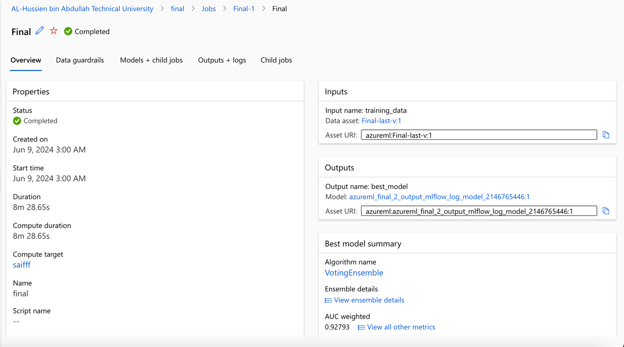

* These were the three best models that gave the best results:

Azure gave me just the best 3 models because I had specified to give me just the best 3 models.

As you can see that votingEnsemble was the best model then MaxAbsScaler, LightGBM then MaxAbsScaler, XGBoostClassifier

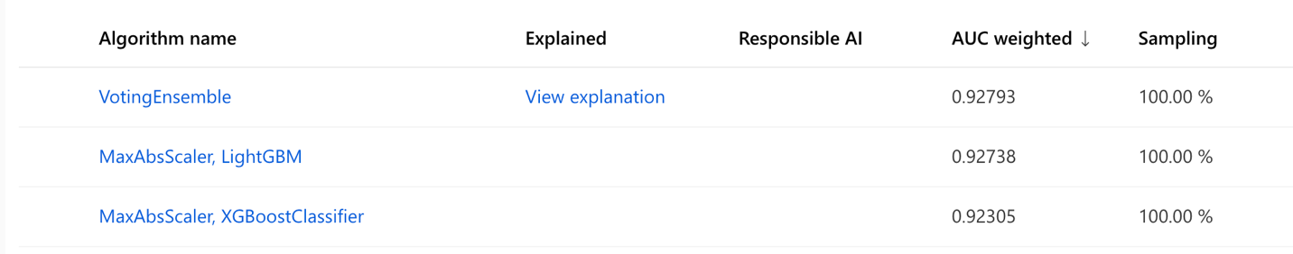

* VotingEnsemble has the highest Area Under the Curve

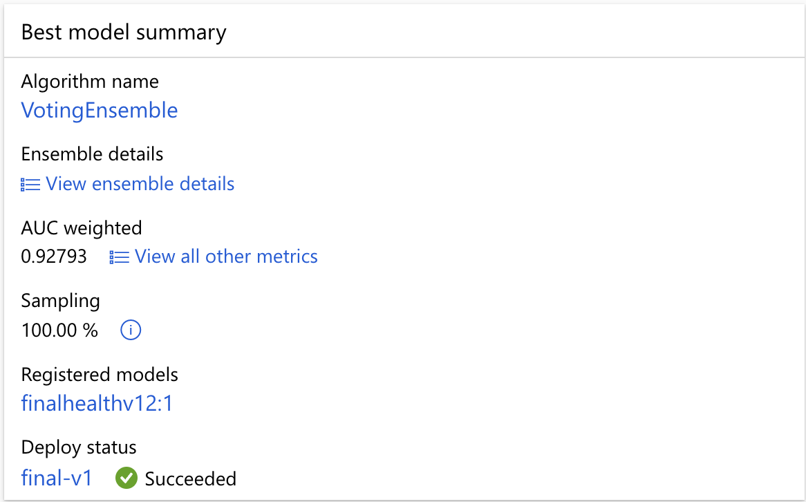

* Here is a proof that the task type was classification.

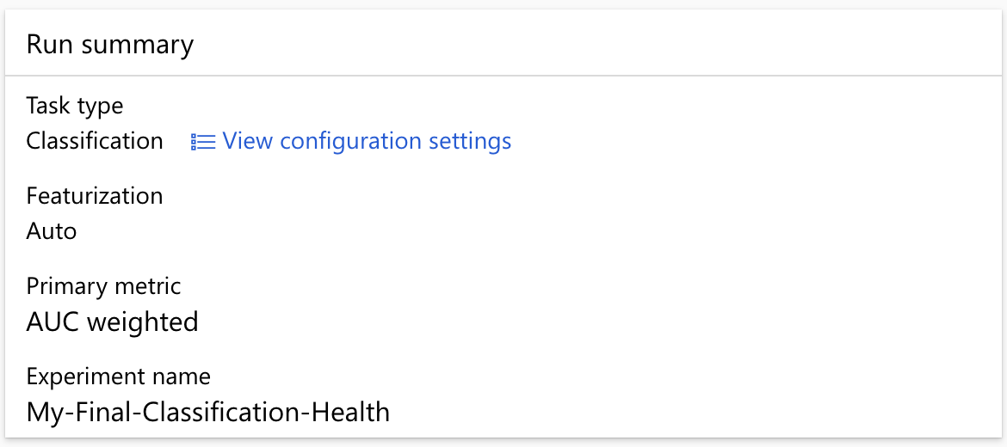

* As we can see here the importance of each feature in the dataset.

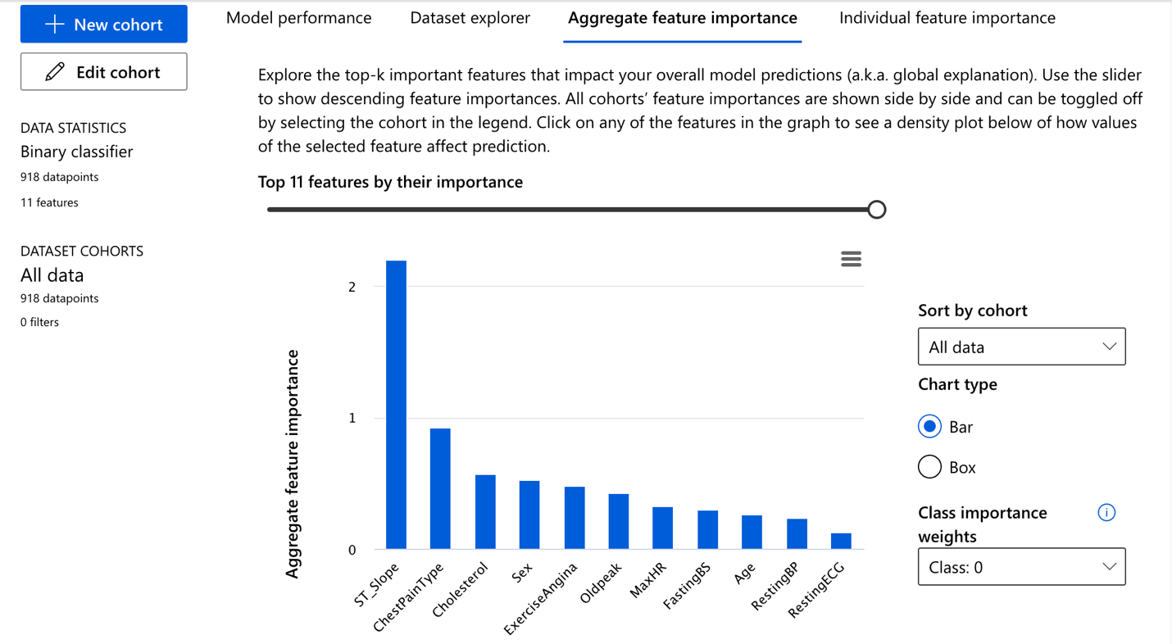

* Here are all the preformance results of the best model.

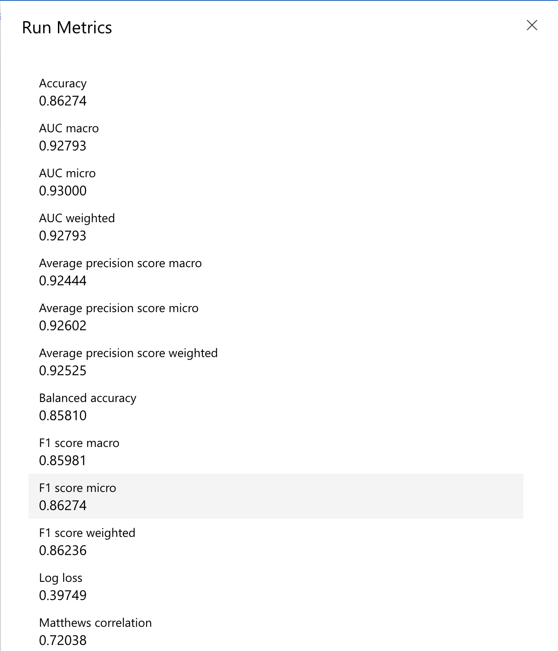



* **Comparing the results before Modification and after modification:**
  + **The results of the measures:**

|  |  |  |
| --- | --- | --- |
|  | Logistic Regression (Colab): | Voting Ensemble (Azure): |
| **Accuracy**: | 84.24% | 86.27 |
| **Precision (Macro Avg.)**: | 84% | 86.23% |
| **Recall (Macro Avg.):** | 85% | 85.81% |
| **F1 Score (Macro Avg.)**: | 84% | 85.98% |

* + **Accuracy:**

The Azure's Voting Ensemble model has achieved higher accuracy which is 86.27% compared to Logistic Regression the accuracy that this model achieved is 84.24% this shows that the ensemble model has predicted more accurately than the Logistic Regression.

* + **Precision (Macro Average):**

The ensemble model achieves a higher precision which is 86.23% compared to Logistic Regression which achieves 84%, this shows that the ensemble model has a higher strength of correctly identifying positive samples.

* + **Recall (Macro Average):**

The ensemble model achieves higher recall which is 85.8% compared to Logistic Regression which achieves 85%.

* + **F1 Score (Macro Average):**

The ensemble model achieves a higher F1 Score which is 85.98% compared to Logistic Regression which achieves 84%, this shows that the ensemble model has made a balance between the precision and the recall better than the logistic regression

* Conclusion:  
  As you can see through the results that Azure was better than Colab which gave more accurate results and performed better than Colab and it was a good modification

## **Q5: Deploy the system**

* I have deployed the best model

As you can see in the screenshot I have submitted the task and it is running.

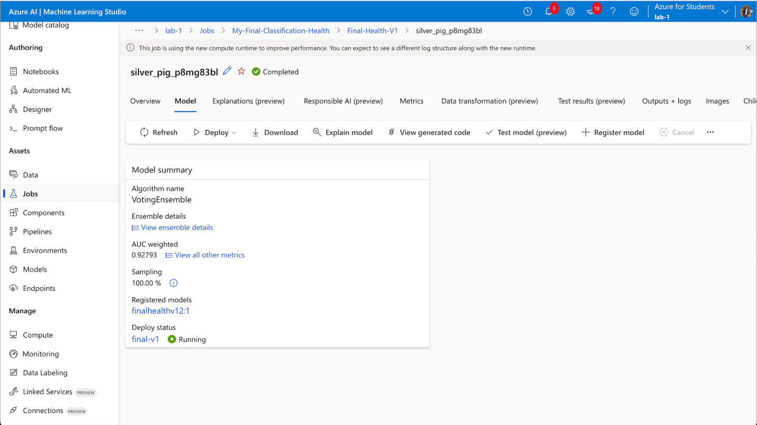

* In this screenshot, you can see that the task proccing has finished (succeeded) and the model is deployed

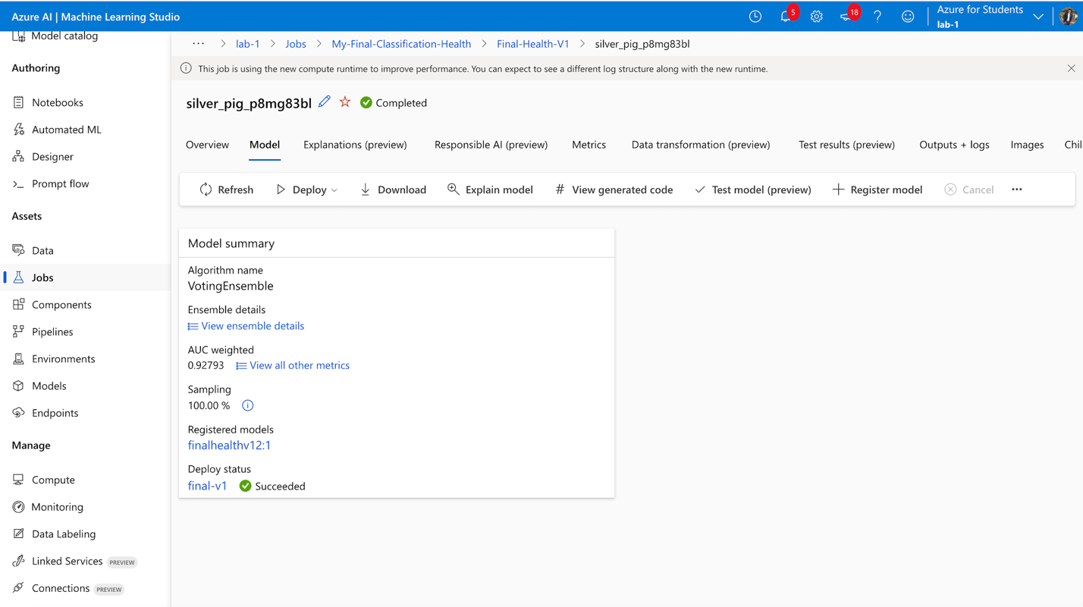

* I have tested the deployed model:

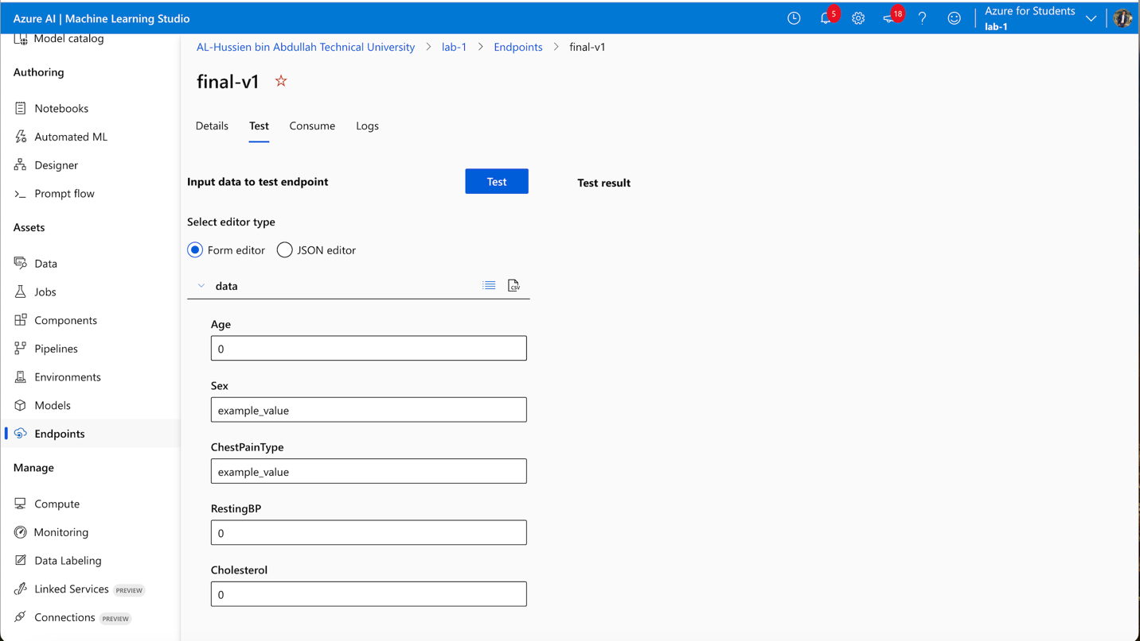

* As you can see in this screenshot I have inserted the values and the result was right.

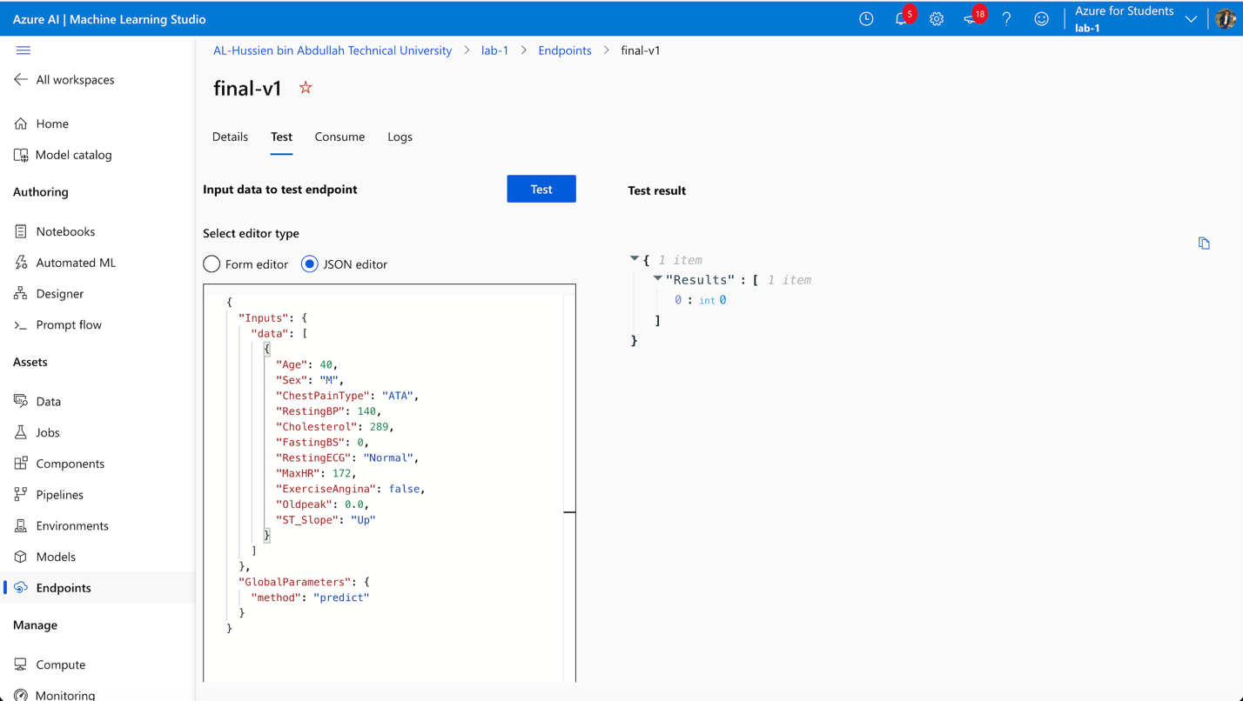

## **Q6:**

* **Evaluation of the machine learning logistic regression classifier method:**
  + **Strength and impact:**
    - **Simplicity and Interpretability:**

The first advantage is that logistic regression is simple to use and understand and also gives clear findings. This makes it particularly helpful in medical environments where it's important to understand how every component affects the final result. (panelLuis H. John a et al., 2022) (Weigard & Spencer, 2023)

* + - **Efficiency:**

The second advantage it works well for fast modeling and iterative testing because of its computational speed. This enables a quicker conclusion in clinical research by enabling quick hypothesis testing and model validation. (panelLuis H. John a et al., 2022) (Weigard & Spencer, 2023)

* + - **Probabilistic Interpretation:**

The third advantage is that this model offers prediction probabilities, which are similar to risk levels. This is particularly helpful in healthcare environments when knowing the probability of a disease occurring can help with decision-making. It helps in classifying patients according to urgency and risk groupings. (panelLuis H. John a et al., 2022) (Weigard & Spencer, 2023)

* + - **Feature Importance:**

The fourth advantage is that the relevance or effect of each attribute can be shown by its coefficient. This can direct preventative actions by assisting and recognizing the important risk factors related to heart disease. (panelLuis H. John a et al., 2022) (Weigard & Spencer, 2023)

* + **weaknesses and impact:**
    - **Linearity:**

The first disadvantage of the method that it assumes that there is a direct relationship between the target feature and the independent features. Heart disease risk feature might interact in non-linear ways that our model fails to capture, which could result in interactions that are missed and oversimplified predictions. (panelLuis H. John a et al., 2022) (Weigard & Spencer, 2023)

* + - **Performance on Non-Linear Problems:**

The second disadvantage poor results can seen as an output when there are non-linear correlations between the variables. This might lead to underfitting and which means that the model makes incorrect predictions about the risk of heart disease and this causes missing to identify important patterns in the data. (panelLuis H. John a et al., 2022) (Weigard & Spencer, 2023)

* + - **Sensitivity to Imbalanced Data:**

The third disadvantage is that may have a bias in using an unbalanced dataset. The method may show a bias for predicting the majority class if the dataset contains more healthy people than those with heart illness, which would lower its sensitivity to identify heart disease. (panelLuis H. John a et al., 2022) (Weigard & Spencer, 2023)

* + - **Outlier Sensitivity:**

The fourth disadvantage is that this method is sensitive to outliers, which have the ability to significantly affect the model. The model's predictions may be affected by outliers, which might have significant effects in a healthcare context if patients' heart disease risk is overestimated or underestimated. (panelLuis H. John a et al., 2022) (Weigard & Spencer, 2023)

* **Improvement:**
  + **Cross-Validation:**

Apply cross-validation techniques to improve any model performance, which means using K-folds that split the data into multi-training parts and validation which make the model train on each instance at least one time this will improve the performance a lot.

* + **Regularization Techniques:**

To reduce overfitting and enhance model generalization apply L1 or L2 regularization. These techniques which are the L1 and L2 use penalties that help in feature selection, especially L1 which can delete a feature by giving it 0 coefficients.

* + **Ensemble Methods:**

Use the ensemble method which means applying multiple models and then taking the average rather than applying just one model.

* + **Trying Different Algorithms:**

Use other classification algorithms such as decision trees, neural networks, and support vector machines that may be more suitable for complicated datasets and non-linear data sets.

* + **Hyperparameter Tuning:**

To find the most suitable parameters for the logistic regression model or any other algorithms use grid search

## **Q7:**

* **Overview of my system:**

The system that I have built uses logistic regression to predict the risk of heart disease and these predictions are done based on a number of physiological and medical characteristics.

* **Some of the issues that can be solved by my developed system:**
  + **To Detect the Heart Disease Early**

The delays in the recognition of heart problems can lead to so bad current medical conditions. By using my developed system we can make early heart disease predictions based on the patient’s medical examinations without the need to wait to see any symptoms, all this can be done by our system which gives us the ability to schedule early medical procedures that can stop the disease's development based on the prediction that this system done. (itransition, 2022) (FWS, 2024)

* + **Efficiently use of the medical staff and clinic resources:**

Sometimes a doctor is unable to accurately assess the degree of danger. For instance, a doctor may mistakenly classify a patient as having a very critical disease when, in fact, it is not that bad. As a result, the staff may be instructed to take extra care of the patient and put him in the intensive care unit (ICU) when it is not necessary.. But using the developed system the doctor can easily know the level of danger that the patients need with a very small error all this is because the system has a lot of data that can make decisions and this lead to efficiently making use of the medical staff that make them to pay attention to the correct location and to the patient who actually needs this special care, also the efficiently use of the ICU rooms to be used only for the patients who need these rooms. (itransition, 2022) (FWS, 2024)

* + **Help Doctors to Make Decisions:**

Sometimes patients do not have the ability to make make all the required health tests because of their high cost so in cases where the patients do not provide full and strong data, the doctor will be uncertain about making decisions. But using the developed system which is already seen in thousands of these cases or close to this case and has a lot of data that can depend on it helps the doctor a lot because the system can make a clear decision that is built based on clear factors and empirical evidence which can show the level of risk and the probabilities of heart disease. (itransition, 2022) (FWS, 2024)

# **Part (3) Top-down Approach:**

## **Q1:**

* **Top-down Approach**

The top-down method of artificial intelligence starts with a high-level system overview, in which the primary goals and architecture of the system are initially determined. The system is broken up into smaller, easier-to-manage components; this split is often made based on the general architecture. (Muir, 2024) (Simplilearn, 2024).

* + **Techniques in Top-down Approaches:**
    - **Knowledge-Based Systems:**

These systems draw conclusions and take actions based on an enormous amount of structured data and rules. By offering diagnostic recommendations based on patient data and an established set of medical standards, knowledge-based technologies in the healthcare industry can help in clinical decision-making. (Simplilearn, 2024) (Sutton et al., 2020)

* + - * **Example:**

Many banks evaluate loan applications using rule-based systems, which use rules to figure out the financial ability of the applicants.

* + - * **Advantages:** (Lane, 2022)
        + Have consistent recommendations.
        + Can handle large amounts of data
      * **Disadvantage:** (Lane, 2022)
        + Needs clear rules
        + Low performance
    - **Fuzzy Logic:**

Instead of handling precise and fixed reasoning, artificial intelligence (AI) employs fuzzy logic to handle approximative reasoning. Medical systems may employ fuzzy logic to assess subjective or ambiguous medical data, such pain thresholds or symptom severity, and form conclusions based on precise but ambiguous data. (Simplilearn, 2024) (Sutton et al., 2020)

* + - * **Advantages:** (Hackr.io, 2022)
        + Flexible and can deal and build complex systems
        + Can deal with uncertain information very good
      * **Disadvantage:** (Hackr.io, 2022)
        + Black box humans can not understand hoe the decision was made.
    - **Logical Reasoning:**

Methods that support claims, find new information, and resolve problem using formal logic. (Simplilearn, 2024) (Sutton et al., 2020)

* + - * **Deductive Reasoning:**

Makes conclusions by applying general rules to particular situations. (Sutton et al., 2020) (Bhandari, 2023)

* + - * **Inductive Reasoning:**

Makes generalizations from specific cases. (Sutton et al., 2020) (Bhandari, 2023)

**Example:**

Logical reasoning is used by automated theorem provers and some natural language processing technologies to effectively analyze and respond to human conversation. (Sutton et al., 2020) (Bhandari, 2023)

* + - * **Advantages:** (Quora, 2022)
        + Provides clear and logical outputs.
        + Very good at solving problems.
      * **Disadvantage:** (Quora, 2022)
* Because it follows established rules, the outputs could be restricted.
* Can not add any new data before updating the rules
  + - **Expert Systems:**

The technique applies high-level information and decision-making rules that have been obtained from experts. Expert systems analyze patient data against a predefined set of rules to recommend treatments. They are used to make choices in certain fields, such as medical diagnostics. These systems use a knowledge base and a set of rules that guide the decision-making process. (Simplilearn, 2024) (Sutton et al., 2020)

* + - * **Example:**

One of the first expert systems is MYCIN this system was created in the 1970s to detect bacteria that cause serious illnesses and to suggest medications. (Simplilearn, 2024) (Sutton et al., 2020)

* + - * **Advantages:** (javatpoint, 2022)
        + Provides consistent decision-making.
      * **Disadvantage:** (javatpoint, 2022)
        + Need predefined rules
        + Can not deal with anything without have the rule of it
  + **Tools for Implementing Top-Down Approaches:**
    - **Expert Systems Tools:**
      * **CLIPS (C Language Integrated Production System):** A rule-based programming language designed for the creation of expert systems. (Simplilearn, 2024) (researchgate, 2024) (inria)
      * **Advantages:** (MetaGuide, 2022)
        + Efficient and flexible rule-based programming
      * **Disadvantage:** (MetaGuide, 2022)
        + Hard to make maintains as to debug erros
    - **Logical Reasoning Tools:**
      * **Prolog:** A logic programming language associated with artificial intelligence and computational linguistics. (Simplilearn, 2024) (researchgate, 2024) (inria)
      * **Advantages:** (indeed, 2022)
        + Strong support for symbolic reasoning and pattern matching.
      * **Disadvantage:** (indeed, 2022)
        + Not as efficient for numerical computations.
    - **Knowledge-Based Systems Tools:**
      * Clips: Integrated manufacturing system for the C language
        + **Advantages**: (researchgate, 2022)  
          The compilation nature allows for quick execution.   
          Since it is written in C, it supports a rule-based system and has great portability.
        + **disadvantages**: (researchgate, 2022)  
          The GUI's (graphical user interface) capabilities are limited.
    - **Fuzzy Logic Tools:**
      * **MATLAB Fuzzy Logic Toolbox:**

This tool gives designers of systems that handle uncertainty and fuzzy logic reasoning tools(Simplilearn, 2024) (researchgate, 2024) (inria)

* + - * **Advantages**: (MATLAB, 2022)
        + Provide easy ways to build fuzzy logic systems
        + Can make combinations dealing with other MATLAB's toolboxes
      * **Disadvantage**: (MATLAB, 2022)
        + High cost because you have to buy Matlab first
        + Do not perform well with simple fuzzy logic systems
  + **Advantages of Top-Down Approaches:**
    - **Structured and Systematic Development:**

Top-down techniques offer a well-defined project plan from the beginning by defining the general architecture and functionality before getting into the details of the project. This structured procedure helps in the systematic management and application of complex AI systems. (Muir, 2024) (Simplilearn, 2024)

* + - **Clear Requirements and Goal Alignment:**

Top-down methods make sure that from the beginning and also make sure the development of the entire system is in line with well-specified objectives. It also ensures that every system component directly contributes to the set objectives, which is essential for projects where particular outcomes are required. (Muir, 2024) (Simplilearn, 2024)

* **Ease of Troubleshooting and Maintenance:**

Finding and fixing problems in each part is much easier with a well-defined structure. Updating and maintaining the system can be done systematically and without accidentally damaging other areas of the system. Because these specific parts can be changed or replaced without impacting the system's overall operation. (Muir, 2024) (Simplilearn, 2024)

* + **Disadvantages of Top-Down Approaches:**
    - **Inflexibility and Resistance to Change:**

Modifying the fundamental architecture or goals of the system can be difficult and expensive once development has started. This inflexibility may be a major disadvantage in dynamic sectors where objectives might change in response to new findings or technological advancements. (Muir, 2024) (Simplilearn, 2024)

* + - **Scalability Issues:**

If future expansions or changes were not fully planned in the initial design, the systems that were created using a top-down method could face scalability challenges. (Muir, 2024) (Simplilearn, 2024)

* + - **Creativity Limitation:**

the structural nature of top-down approaches just focuses on the predefined rules and objectives rather than exploring new ideas or alternative solutions, which means that we can achieve creativity and innovation in the created systems. (Muir, 2024) (Simplilearn, 2024

## **Q2:**

* **Chatbot using Top-down Approach:**

I have created a chatbot and it is a rule-based system. This system is made for a heart disease clinic to make the patient stay engaged and provide helpful information. This system contains text and multiple-choice to allow users to have clear and helpful options and to be easy to use. This chatbot provides a number of services, such as general heart health information, explanations of medical tests like cholesterol and blood pressure readings, lifestyle tips for preventing heart disease, and a comprehensive section that displays the clinic's schedule for every day of the month.

## **Q3:**

* **Test the system and analyze the test results:**

I have done manual testing on this chatbot, and this testing process has covered multiple scenarios to ensure that each feature of this chatbot behaves as expected. The tests included user interactions such as entering valid and invalid choices and assessing the response accuracy.

* **Things that have been tested:**
  + **Functions:**
    - **General Information about Heart Health:**

The chatbot successfully gives detailed information about heart diseases and symptoms when this choice is picked and it also shows the sub-options for more detailed symptom information when I picked the deeper level option. This chatbot responds correctly when option 1 is picked, and it shows options for heart disease overview and common symptoms.

Additionally, I tested it by choosing the Heart Disease Overview choice for the second level depth, and it displayed accurate information regarding heart disorders.

Also, the second deeper lever choice, which is (Common Symptoms), was examined. It provided correct information and guided me to more choices like (Chest Pain) and (Shortness of Breath).

* + - **Medical Test Explanations:**

When the second choice is selected, the chatbot effectively offers full details regarding blood pressure and cholesterol levels. It also clearly explains these medical tests, allowing for a full understanding of the test findings.

* + - **Lifestyle Advice:**

When the third option is selected, it successfully provides comprehensive information about diet and exercise, including recommendations for how often to perform aerobic, strength, and flexibility exercises that provide an overview of general health guidelines.

* + - **Clinic Working Hours:**

After choosing a specific month and day when the number 4 option is selected, the chatbot successfully delivers detailed information about the clinic's operating hours. The accuracy of the results depended on the number of options chosen which were the month inputs (1–12) and the day inputs (1–7). After testing every option, everything went smoothly, and I had to ensure that the moving between the levels based on the choices made was accurate.

* + **Error Handling:**

After testing every option in the chatbot, I made sure that it would not crash or freeze in the event that a number outside of its allowed range was entered. I also made sure that the chatbot would respond appropriately if a non-integer input was entered.

* + **Performance Testing:**

I have tested the response time of the chatbot when any option is picked and it was very fast to show the information in case it was the final level, In addition, if I choose a choice with many levels, it moved quickly between levels.

* **Conclusion:**

## **Functionality:** The chatbot's functionalities all operated as intended, giving precise and in-depth information in response to user input.

## **Performance:** The chatbot answered promptly and without any hiccups, increasing user happiness and ensuring a seamless chatbot experience.

## **Error Handling:** By forcing the user to start over and provide legitimate options again, the chatbot system quickly and efficiently handles invalid inputs, reducing user annoyance and improving the quality of the entire interaction.

## **Q4:**

* **Overview:**

In healthcare sectors especially in clinics like a Heart Health Clinic is very important to provide accurate information to patients. Rule-based chatbots are frequently used in these environments to help with patient questions and also for health education and to improve clinic operations. These chatbots function based on predefined sets of rules.

* **Evaluation of the Rule-Based Chatbot System:**
  + **Strengths and Impact:**
    - **Determinism and Consistency:**

The first advantage of the rule rule-based chatbot in the heart health sector is that it is determinism and this is shown when specific input is given our chatbot will always give the same output this shows that the information is accurate and consistent every time and in all cases and this is gives a real strength to out chatbot because it is very help full in health care sectors where the safety of patients is very important through giving correct answers and also it raises the patient trust through consistent answers, in more details this would really impact our heart chatbot system when all patients receives the same lastest version of answer information this also let our clinic to make sure that the same level of advice is given for all the patients. (Andrieiev, 2023) (Dr. Liji Thomas, 2022)

* + - **Simplicity and Ease of Maintenance:**

The second advantage is that the rule-based system is so simple for the developer and also for the customer. It is simple for the developer because building a rule-based system does not require complex algorithms and also it does not need advanced computers and equipment to build and run these systems, this gives strength to the heart clinics because the simplicity of the rule-based systems gives the ability to edit and update our chatbot information quickly with any new data which is very important in this sector to ensure that we are keeping up with any advancements. Also, this helps our clinic to easily change their working hours which are shown through the chatbot in case of any changes without wasting time. (Andrieiev, 2023) (Dr. Liji Thomas, 2022)

* + - **High Reliability:**

The third advantage is that using the rule-based system lets us avoid any incorrect self-learning or biases that can happen by machine learning systems, unlike our heart chatbot which is built based on a rule-based because this kind gives answers based on what I program and the patient will get the same which make our chatbot one hundred percent controlled by us. This could really impact our chatbot and our clinic because it makes us make sure that all the information that will be provided is safe which will minimize the errors that could damage patients. (Andrieiev, 2023) (Dr. Liji Thomas, 2022)

* + **weakness and Impact:**
    - **Limited Flexibility and Responsiveness:**

The first disadvantage of the rule-based chatbot is the limited information and answers that could the patients have because the rule-based does not have the ability to understand anything that is not preprogrammed rules which could not be helpful for some of the patients that use our chatbot. This limitation could lead to patient frustration and disengagement and the patient will also feel disappointed with our chatbot and clinic because the patients did not see it as helpful. (Andrieiev, 2023) (Dr. Liji Thomas, 2022)

* + - **No Learning or Adaptation:**

The second disadvantage is as I mentioned before that the rule-based chatbot doesn’t not use machine-learning models which means that the rule-based chatbot does not have the ability to learn over time this means that our chatbot can improve itself. This limitation could lead to more effort by the IT department of the clinic because they will waste a lot of time on daily updating and editing and also in case the updates are not done daily will affect the usefulness of our chatbot (Andrieiev, 2023) (Dr. Liji Thomas, 2022)

* **Recommendations for Improvement:**
  + **Adding Natural Language Processing (NLP):**

Adding NLP to the chatbot system can improve the chatbot a lot because it will enable our chatbot to understand and process a wider range of inputs. This will enable the patient to ask and write whatever he wants and the chatbot will understand and respond to him which will make the patient feel more comfortable and this will raise the accuracy of the answers, in conclusion there will be interaction between the patient and the chatbot as two humans are in a conversation.

* + **Adding Feedback part to the chatbot:**

This means adding a main part to the chatbot called a feedback box so the user put their feedback about what they prefer to be in this chatbot and what issues they face in this chatbot so we can know what parts of the chatbot need to be improved or updated so we can ensure that this chatbot system is helpful to the patients and provide the needs of the patients

## **Q5:**

* **Issue that can be solved using this chatbot that is made based on a rule-based method:**
  + **Information sharing:**

Patients usually need a fast response for information such as they need to know their health condition in emergency cases, information about some treatments before taking it, and also the working time of the clinic and usually the health care sector secretaries are not always available to answer the calls of the patients and answer questions this leads to delays for provide the needs of the patients. Using this rule-based chatbot will provide immediate and accurate answers to the patient’s questions and these answers contain heart health, disease symptoms, and potential treatment information. This ensures that the patients have immediate access to some important information that patients usually ask for it without the need to make calls and waste time trying to contact the clinic. (savvycomsoftware, 2024)

* + **Patient Engagement and Education:**

Patients these days are not fully engaged with how to manage their health, especially for chronic conditions like heart disease. The chatbot could serve as a continuous teaching assistant that gives patients straightforward facts and helpful advice on changing their lifestyles and managing their health conditions. Patients have the ability to become involved in their health and manage it by themselves. (savvycomsoftware, 2024)

* + **Efficiency in Healthcare Service:**

Staff members at medical clinics sometimes have a lot of things to do and they are not always free to balance patient care with job responsibilities and this includes responding to frequently asked questions about clinic services. The chatbot may free up a lot of staff time by automating answers to frequently asked operational questions like clinic hours, and appointment scheduling. This raises overall service efficiency by enabling medical staff to focus more on direct patient care tasks. (savvycomsoftware, 2024)

* + **Difficulty to use to Healthcare Services**

Patients could have difficulties getting health information because of limited clinic hours or transportation and distance constraints. Through the chatbot, the patients can get clinic services at all times from any location. People who live far from the clinic or who might have difficulties with transportation will be happy using this chatbot because of its benefits. (savvycomsoftware, 2024)

# **Part (4) Emerging Technologies:**

## **Q1:**

* **Introduction of the emerging AI technology in health care:**

A significant advancement in healthcare has been made with the development of AI-powered robotic surgery, especially for the treatment of difficult diseases like heart disease. This new technology is a relatively recent addition to healthcare, mixing advanced robotics with complex artificial intelligence algorithms to improve heart treatment with the highest accuracy and control. (MobiHealthNews, 2023)

* **Advantages of the emerging AI technology in Surgery:**

Robotic surgery driven by AI is a new technology that stands out because it improves on traditional surgical techniques by incorporating advanced capabilities like data analysis and real-time imaging. This helps surgeons carry out highly complicated treatments with better safety and accuracy which are the most important two things in heart surgeries. Robotic devices provide the precision needed for operations like valve repairs and coronary artery bypass grafting, where a small mistake can have serious consequences. Additionally, this technology offers low-risk cardiac surgery techniques that significantly decrease recovery periods and minimize physical harm. These advancements reduce risks brought on by human error and potential mistakes also improving surgical results. By adding AI into these systems, surgeons can receive real-time decision assistance that helps them make smart decisions during surgeries and also enables them to adjust their pre-surgical plans when there are sudden changes during surgeries. (MobiHealthNews, 2023) (Mithany et al., 2023)

* **A real-life example of using emerging AI technology in surgeries:**

**Coronary Artery Bypass Grafting (CABG):** Artificial intelligence (AI)--driven robotics is very useful in the field of heart surgery for operations requiring a high degree of control and precision. For example, robotic arms using AI algorithms lead them during coronary artery bypass grafting (CABG), which can help them to do the surgery with minimum cuts which leads to a short recovery period for the patient than with open heart surgery. this technology improves 3D imagery of the patient's heart architecture through augmented reality layers, the AI technologies improve the surgeon's vision and raise flexibility. (MobiHealthNews, 2023) (Tang et al., 2023)

**Valve Surgery:** AI-enhanced robots help surgeons during valve replacement or repair procedures by accurately stitching and placing the new valve. To improve surgical methods and execution, the AI analyzes anatomical data specific to each patient which helps in surgical and real-time feedback and this leads to better recovery results. (MobiHealthNews, 2023) (Benjamin & Rabbat, 2024).

## **Q2:**

* **Introduction:**

the emerging AI has become the most growing technology these days in our lives and also has a big effect on our lives especially in the healthcare sector. The emerging AI has become a very important part of modern treatment manufacturing, and this changes all the steps of how the treatments in managed and produced. This indicates that the emerging ai will change everything in the healthcare sector in the future. (Timspark, 2024) (González, 2024)

* + **Telemedicine and IoMT (Internet of Medical Things):**

A wireless device that can be controlled and monitored using wearable devices without the need to see the patients. These devices collect patient health data in real-time, and using the AI this collected data will be analyzed to assess any problem the patient faces and also can customize treatments based on their conditions. IoMT and telemedicine can surely affect the healthcare sector, especially for those living far away or in areas that don't have clinical. These technologies reduce the total cost of healthcare and reduce the load on medical staff by minimizing the need for frequent hospital visits. It is expected that when telemedicine and IoMT become more widely used, healthcare will become more accessible, and efficient which will lead to improved results for patients and promote more healthcare equity. (Timspark, 2024) (González, 2024) (Manickam et al., 2022)

* + **AI for Disease Prevention:**

Using AI we can now prevent any illness and health care problems that could face patients by giving them a wearable device to keep an eye on. People who are at a high risk of contracting illnesses can be detected using predictive analytics, which enables quick action. AI for avoiding illnesses increases patient longevity and health by changing the focus from reacting to proactive healthcare. This strategy minimizes the need for long stays in hospitals and treatments, which reduces the cost on healthcare systems. It is expected that the use of AI to disease prevention would improve public health outcomes by resulting in healthier populations and more flexible healthcare systems. (Timspark, 2024) (González, 2024) (Wani et al., 2022)

* + **AI as a Personal Assistant:**

AI-driven virtual assistants evaluate large amounts of health data to make personalized treatment suggestions. AI assistants provide regular interaction and keep an eye on mental health by identifying changes in speech patterns and emotional states in older people. AI assistants offer ongoing, customized attention, which increases patient engagement and treatment taking. This assistance improves older people's overall health by lowering signs of desperation and loneliness. AI personal assistants help to improve patient outcomes by reducing some of the responsibilities for medical staff which leads to improved effective and efficient patient care. (Timspark, 2024) (González, 2024) (avnet, 2020)

## **Q3:**

* The emerging AI technologies in healthcare show a clear important change in medical services which have both benefits and challenges, especially in industrial and social perspectives.
* **Starting with the Industrial impact of healthcare sectors:**

The emerging AI technologies are so expensive, especially the technologies that are made for medical needs which are highly accurate and can be trusted. These emerging AI technologies give a high value for the hospitals they use but because of their high cost, not all hospitals and clinics can buy these technologies and this may lead to a technology gap between healthcare hospitals and clinics with greater financial support and those with less financial support. Hospitals that apply these emerging AI technologies may affect the hospital positively because it can attract patients from around the world for treatment in these hospitals which can raise the financial return of the hospital, on the other hand, some hospitals may event and buy these high-cost technologies but patients do not come to these hospitals because from the natural that the prices of these technologies are high, so treatment will be provided using these technologies will be also high and a lot of patients can’t pay for the treatment that is provided by these technologies which could lead to a loss in these hospitals because they have invested a lot of money on these assets and these assets does not return the money also these emerging technologies need to be updated from time to time so the hospital will still pay money without any return. Emerging technology has a good effect on hospital finances, hospitals now have the ability to buy technology just once time rather than paying each month for the staff and these technologies can do the same tasks humans can do, this will allow the hospital to save money and also the tasks will be done accurate and with less time which will raise the productivity of the hospital.

**Moving on to the social impact in healthcare sectors:**

The application of any emerging technology can have a positive impact on society. Some emerging technology allows for remote patient diagnosis. This is considered a powerful advantage in some cases when the patient is very far from hospitals and does not have any kind of transportation this would raise the satisfaction of the patients and make them love these hospitals. It can also have a negative impact because elderly patients do not trust to give their lives to electronic robots which is a kind of emerging technology, and they prefer to stay in their homes and not take treatment because of their fear of this technology which might lead to advanced medical conditions that cannot be treated. It also negatively affects doctors’ society because the language of communication will be non-existent, especially among doctors, because the doctors will interact with technology rather than doctors interact with each other which will lead to a loss of the exchange of viewpoints and experiences between doctors, and it will also negatively affect doctors who like to interact with people and take point of view.

* **Conclusion:**

New AI innovations in healthcare have revolutionized medical practices and present both significant advantages and challenges. These technologies improve operational effectiveness and allow care to be delivered to remote locations, but they are provided at a high cost. Emerging AI could have a negative effect on patients' trust and happiness as well as maybe limit medical staff members' capacity for face-to-face communication all this might happen because of the growing use of technology does not need direct interactions between patients and doctors and nurses, so focusing in this issue and finding a way that allows for improved services without losing personal care and trust is very important.

## **Q4:**

* **Introduction:**

Emerging AI technologies have the ability to change many sectors future, A lot of changes will happen because emerging AI technologies are expanding into more industries which offer potential benefits and difficulties in sectors.

* **Healthcare:**

Starting with the first sector which is healthcare, is the most important sector to discuss the future impact of AI on the sector because my project focuses on healthcare. Using emerging AI technologies can give the ability to analyze data to make customized treatments that suit each patient based on his genetic data and lifestyle this might lead to more accurate and efficient treatments with no side effects, which can affect the future by making people more comfortable and trust the treatments they take because these treatments are made just for a single patient based on his data that it is unique than any other patient. Also using emerging AI technologies such as robotics can make all kinds of surgeries done by robots without the need for human doctors’ help this can lead to increased accuracy and decrease any error that might be done by humans and also reduce recovery times, this can affect the future by making hospitals no more need for doctors which means no more need for this mager and also will affect the future by making patients more comfortable to do surgeries because the psychological factor and mood in robots are not there. (Built In, 2024) (About Sakshi Gupta , 2023) (Talmage-Rostron, 2024)

* **Transportation:**

Using cutting-edge AI technologies in this field will enable all vehicle types to drive autonomously, negating the need for a driver to operate the vehicle or do any other tasks. This will allow drivers of any age to simply get in the car and go, leaving the rest to the car. Additionally, since no driving license is required, fewer accidents caused by human error or distraction will likely occur, as well as less traffic. (Built In, 2024) (About Sakshi Gupta , 2023) (Talmage-Rostron, 2024)

* **Business and Employment:**

Moving on to the third sector which is Business and Employment. Using emerging AI technologies in this sector as employment can be both a helper and an obstacle. Even if there's a chance of losing your work, especially in jobs with repeated tasks, there's a big need for new skills, especially in data analysis and artificial intelligence. But for the business AI is being used more and more to automate business operations, such as complicated data analysis and customer support tasks that chatbots can do. Cost reductions and better efficiency may result from this also leads to customers not needing to contact any human and wast time in case the calling line is busy. (Built In, 2024) (About Sakshi Gupta , 2023) (Talmage-Rostron, 2024)

* **Media:**

The ability of AI to automate media content generation could bring in a time of hyper-personalized content consumption. Artificial intelligence has the ability to become a primary creator of original content in the future, challenging established notions about creativity and intellectual property. Although this has the ability to make more accessible the creation of content, it also brings up issues with the spread of false information and the need for trustworthy techniques to validate content generated by artificial intelligence. (Built In, 2024) (About Sakshi Gupta , 2023) (Talmage-Rostron, 2024)

# **References:**

## **Part (1)** **References:**

## **Q1:**

NuAIg.ai (2020) *Top 5 philosophical issues of Artificial Intelligence (AI)*, *Medium*. Available at: https://intelligence-in-aiml.medium.com/top-5-philosophical-issues-of-artificial-intelligence-ai-fa2025777078 (Accessed: 29 May 2024).

AlmaBetter (2022) *Expert system in Ai*, *AlmaBetter*. Available at: https://www.almabetter.com/bytes/tutorials/artificial-intelligence/expert-system-in-ai (Accessed: 29 May 2024).

Author *et al.* (2024) *Artificial Intelligence: An introduction to ai fundamentals*, *Redress Compliance - Just another WordPress site*. Available at: https://redresscompliance.com/artificial-intelligence-an-introduction-to-ai-fundamentals/#:~:text=The%20functioning%20of%20Artificial%20Intelligence,%2C%20perceive%2C%20and%20make%20decisions. (Accessed: 29 May 2024).

Laskowski, N. and Tucci, L. (2024) *What is Artificial Intelligence (AI)? everything you need to know*, *Enterprise AI*. Available at: https://www.techtarget.com/searchenterpriseai/definition/AI-Artificial-Intelligence (Accessed: 29 May 2024).

Zellers, A. and Talingting, V. (2023) *The benefits of AI in Healthcare & 8 major ai types in 2023*, *ChartRequest*. Available at: https://chartrequest.com/benefits-of-ai-in-healthcare-2023/ (Accessed: 29 May 2024).

## **Q2:**

World Economic Forum (2022) *Top 9 ethical issues in Artificial Intelligence*, *World Economic Forum*. Available at: https://www.weforum.org/agenda/2016/10/top-10-ethical-issues-in-artificial-intelligence/ (Accessed: 29 May 2024).

Tai, M.C.-T. (2020) *The impact of Artificial Intelligence on Human Society and Bioethics*, *Tzu chi medical journal*. Available at: https://www.ncbi.nlm.nih.gov/pmc/articles/PMC7605294/ (Accessed: 29 May 2024).

qualcomm (2022) *The positive social impact of AI*, *Wireless Technology & Innovation*. Available at: https://www.qualcomm.com/news/onq/2023/11/the-positive-social-impact-of-ai (Accessed: 29 May 2024).

Krasadakis, G. (2023) *The impact of AI on society and Everyday Life*, *Medium*. Available at: https://medium.com/60-leaders/the-impact-of-ai-on-society-and-everyday-life-711307e06b87#:~:text=Some%20of%20the%20benefits%20of,%2C%20law%20enforcement%2C%20and%20transportation. (Accessed: 29 May 2024).

Ideta (2022a) *How artificial intelligence has evolved over the years*, *Ideta*. Available at: https://www.ideta.io/blog-posts-english/how-artificial-intelligence-has-evolved-over-the-years#:~:text=The%20evolution%20of%20AI%20has,%2C%20and%20voice%2Dactivated%20assistants. (Accessed: 29 May 2024).

Joanna J. Bryson                                                                                                    University of Bath, Bryson, J.J. and Bath, U. of (2022) *The past decade and future of AI’s impact on Society*, *OpenMind*. Available at: https://www.bbvaopenmind.com/en/articles/the-past-decade-and-future-of-ais-impact-on-society/ (Accessed: 29 May 2024).

## **Q3:**

Writer, G. (2023) *8 helpful everyday examples of artificial intelligence*, *IoT For All*. Available at: https://www.iotforall.com/8-helpful-everyday-examples-of-artificial-intelligence (Accessed: 29 May 2024).

Marr, B. (2024) *10 wonderful examples of using artificial intelligence (AI) for good*, *Forbes*. Available at: https://www.forbes.com/sites/bernardmarr/2020/06/22/10-wonderful-examples-of-using-artificial-intelligence-ai-for-good/?sh=6933314b2f95 (Accessed: 29 May 2024).

## **Part (2) References:**

## **Q1:**

Simplilearn (2024) *Top down approach vs. bottom up approach: Understanding the differences*, *Simplilearn.com*. Available at: https://www.simplilearn.com/top-down-approach-vs-bottom-up-approach-article (Accessed: 30 May 2024).

Staging TD (2024) *Bottom-up approach*, *Staging TD*. Available at: https://www.trusteddecisions.com/en/wiki/bottom-up-approach/#:~:text=A%20key%20feature%20of%20the,to%20form%20an%20overall%20process. (Accessed: 30 May 2024).

researchgate (2022) *(PDF) Swarm Intelligence and flocking behavior*. Available at: https://www.researchgate.net/publication/331249652_Swarm_Intelligence_and_Flocking_Behavior (Accessed: 29 May 2024).

Mudadla, S. (2023) *Most useful machine learning and deep learning python libraries.*, *Medium*. Available at: https://medium.com/@sujathamudadla1213/most-useful-machine-learning-and-deep-learning-python-libraries-67c5b7ca8a4c (Accessed: 30 May 2024).

JohannesJohannes                      33633 silver badges99 bronze badges *et al.* (1960) *What is the responsibility or benefit of a tokenizer?*, *Software Engineering Stack Exchange*. Available at: https://softwareengineering.stackexchange.com/questions/240255/what-is-the-responsibility-or-benefit-of-a-tokenizer (Accessed: 09 June 2024).

GeeksforGeeks (2023) *Advantages and disadvantages of Deep Learning*, *GeeksforGeeks*. Available at: https://www.geeksforgeeks.org/advantages-and-disadvantages-of-deep-learning/ (Accessed: 09 June 2024).

DataFlair, D. (2024) *Advantages and disadvantages of machine learning language*, *DataFlair*. Available at: https://data-flair.training/blogs/advantages-and-disadvantages-of-machine-learning/ (Accessed: 09 June 2024).

upGrad blog (2023) *Scikit-learn in Python: Features, prerequisites, pros & cons*, *upGrad blog*. Available at: https://www.upgrad.com/blog/scikit-learn-in-python/ (Accessed: 09 June 2024).

Singh, A. (2018) *Azure machine learning benefits & pitfalls*, *LinkedIn*. Available at: https://www.linkedin.com/pulse/azure-machine-learning-benefits-pitfalls-singh-cloud-big-data (Accessed: 09 June 2024).

DataFlair, D. (2021) *Python keras advantages and limitations*, *DataFlair*. Available at: https://data-flair.training/blogs/python-keras-advantages-and-limitations/ (Accessed: 09 June 2024).

linkedin (2022) *What are the benefits and challenges of using NLTK for text mining tasks?*, *NLTK for Text Mining: Benefits and Challenges*. Available at: https://www.linkedin.com/advice/0/what-benefits-challenges-using-nltk-text-mining-tasks#:~:text=NLTK%20has%20many%20advantages%2C%20but,mining%2C%20such%20as%20deep%20learning. (Accessed: 09 June 2024).

## **Q6:**

Weigard, A. and Spencer, R.J. (2023) *Benefits and challenges of using logistic regression to assess neuropsychological performance validity: Evidence from a simulation study*, *The Clinical neuropsychologist*. Available at: https://www.ncbi.nlm.nih.gov/pmc/articles/PMC9273108/ (Accessed: 30 May 2024).

Author links open overlay panelLuis H. John a *et al.* (2022) *Logistic regression models for patient-level prediction based on massive observational data: Do we need all data?*, *International Journal of Medical Informatics*. Available at: https://www.sciencedirect.com/science/article/pii/S1386505622000764 (Accessed: 30 May 2024).

## **Q7:**

itransition (2022) *Machine learning in Healthcare: 10 use cases, Examples & Benefits*, *Machine Learning In Healthcare: 10 Use Cases, Examples & Benefits*. Available at: https://www.itransition.com/machine-learning/healthcare (Accessed: 30 May 2024).

FWS (2024) *Top 10 applications of machine learning in Healthcare*, *FWS*. Available at: https://www.flatworldsolutions.com/healthcare/articles/top-10-applications-of-machine-learning-in-healthcare.php (Accessed: 30 May 2024).

## **Part (3) References:**

## **Q1:**

Muir, C. (2024) *Top-down AI: Simplifying Complex Problem Solving*, *TopApps.Ai*. Available at: https://topapps.ai/blog/top-down-ai/#:~:text=these%20different%20approaches.-,Top%2Ddown%20approach,guide%20the%20AI%20system’s%20behavior. (Accessed: 30 May 2024).

Simplilearn (2024) *Top down approach vs. bottom up approach: Understanding the differences*, *Simplilearn.com*. Available at: https://www.simplilearn.com/top-down-approach-vs-bottom-up-approach-article (Accessed: 30 May 2024).

researchgate (2024) *(PDF) a tool for automatic creation of rule-based expert systems with CFS*. Available at: https://www.researchgate.net/publication/225105790_A_Tool_for_Automatic_Creation_of_Rule-Based_Expert_Systems_with_CFs (Accessed: 29 May 2024).

Sutton, R.T. *et al.* (2020) *An overview of clinical decision support systems: Benefits, risks, and strategies for Success*, *NPJ digital medicine*. Available at: https://www.ncbi.nlm.nih.gov/pmc/articles/PMC7005290/ (Accessed: 30 May 2024).

inria (no date) *Chercheurs Inria : Participez Au Halathon 2024*, *inria*. Available at: https://inria.hal.science/ (Accessed: 30 May 2024).

Bhandari, P. (2023) *What is deductive reasoning?: Explanation & examples*, *Scribbr*. Available at: https://www.scribbr.com/methodology/deductive-reasoning/#:~:text=Deductive%20reasoning%20is%20a%20logical,logic%20or%20top%2Ddown%20reasoning. (Accessed: 30 May 2024).

Hackr.io (2022) *What is Fuzzy Logic? advantages and disadvantages*, *Hackr.io*. Available at: https://hackr.io/blog/what-is-fuzzy-logic (Accessed: 09 June 2024).

indeed (2022) *What is Prolog? (definition, components and applications)*. Available at: https://in.indeed.com/career-advice/career-development/what-is-prolog (Accessed: 09 June 2024).

javatpoint (2022) *Advantages and disadvantages of expert system - javatpoint*, *www.javatpoint.com*. Available at: https://www.javatpoint.com/advantages-and-disadvantages-of-expert-system (Accessed: 09 June 2024).

Lane, R. (2022) *Pros & Cons of using a knowledge base in your company*, *The ScreenSteps Learning Center for Call Centers and Employee Support*. Available at: https://blog.screensteps.com/pros-cons-knowledge-base (Accessed: 09 June 2024).

MATLAB (2022) *Advantages of MATLAB: Disadvantages of Matlab*, *Advantages of MATLAB | Disadvantages of MATLAB*. Available at: https://www.rfwireless-world.com/Terminology/Advantages-and-Disadvantages-of-MATLAB.html (Accessed: 09 June 2024).

MetaGuide (2022) *Clips (C Language Integrated Production System)*, *MetaGuidecom*. Available at: https://meta-guide.com/expert-systems/clips-c-language-integrated-production-system (Accessed: 09 June 2024).

Quora (2022) *What are the advantages and disadvantages of logic in Artificial Intelligence?*, *Quora*. Available at: https://www.quora.com/What-are-the-advantages-and-disadvantages-of-logic-in-artificial-intelligence (Accessed: 09 June 2024).

researchgate (2022) *(PDF) Knowledge Based System Development Tools*. Available at: https://www.researchgate.net/publication/321225118_Knowledge_based_system_development_tools (Accessed: 09 June 2024).

## **Q4:**

Andrieiev, S. (2023) *Healthcare Chatbots Overview: Role of AI, benefits, examples*, *LinkedIn*. Available at: https://www.linkedin.com/pulse/healthcare-chatbots-overview-role-ai-benefits-sasha-andrieiev#:~:text=These%20simple%20rule%2Dbased%20chatbots,shares%20a%20generic%20fallback%20answer. (Accessed: 30 May 2024).

Dr. Liji Thomas, M. (2022) *The Pros and cons of Healthcare Chatbots*, *News*. Available at: https://www.news-medical.net/health/The-Pros-and-Cons-of-Healthcare-Chatbots.aspx (Accessed: 30 May 2024).

## **Q5:**

savvycomsoftware (2024) *Top 10 use cases conversational AI in Healthcare*, *Top 10 Use Cases Conversational AI In Healthcare*. Available at: https://savvycomsoftware.com/blog/conversational-ai-in-healthcare/ (Accessed: 30 May 2024).

## **Part (4) References:**

## **Q1:**

MobiHealthNews (2023) *Contributed: Nine revolutionary ways AI is Advancing Healthcare*, *MobiHealthNews*. Available at: https://www.mobihealthnews.com/news/contributed-nine-revolutionary-ways-ai-advancing-healthcare (Accessed: 28 May 2024).

Mithany, R.H. *et al.* (2023) *Advancements and challenges in the application of artificial intelligence in Surgical Arena: A literature review*, *Cureus*. Available at: https://www.ncbi.nlm.nih.gov/pmc/articles/PMC10613559/#:~:text=In%20intraoperative%20guidance%2C%20AI%20aids,%2Drobot%20collaboration%20%5B13%5D. (Accessed: 28 May 2024).

Tang, X. *et al.* (2023) *Artificial Intelligence and Big Data Technologies in the construction of surgical risk prediction model for patients with coronary artery bypass grafting*, *Computational intelligence and neuroscience*. Available at: https://www.ncbi.nlm.nih.gov/pmc/articles/PMC10348861/ (Accessed: 28 May 2024).

Benjamin, M.M. and Rabbat, M.G. (2024) *Artificial Intelligence in Transcatheter Aortic Valve Replacement: Its current role and ongoing challenges*, *Diagnostics (Basel, Switzerland)*. Available at: https://www.ncbi.nlm.nih.gov/pmc/articles/PMC10855497/ (Accessed: 28 May 2024).

## **Q2:**

Timspark (2024) *Future of AI in healthcare: Trends to watch in 2023-2024*, *Timspark*. Available at: https://timspark.com/blog/future-of-ai-in-healthcare-trends-2023-2024/ (Accessed: 28 May 2024).

Gonz&aacute;lez, B. (2024) *How will artificial intelligence change the future of healthcare?*, *UOC*. Available at: https://www.uoc.edu/en/news/2024/how-will-artificial-intelligence-change-the-future-of-healthcare (Accessed: 28 May 2024).

Manickam, P. *et al.* (2022) *Artificial Intelligence (AI) and internet of medical things (IOMT) assisted biomedical systems for Intelligent Healthcare*, *Biosensors*. Available at: https://www.ncbi.nlm.nih.gov/pmc/articles/PMC9330886/ (Accessed: 29 May 2024).

Wani, S.U.D. *et al.* (2022) *Utilization of Artificial Intelligence in disease prevention: Diagnosis, treatment, and implications for the healthcare workforce*, *Healthcare (Basel, Switzerland)*. Available at: https://www.ncbi.nlm.nih.gov/pmc/articles/PMC9026833/ (Accessed: 29 May 2024).

avnet (2020) *How ai-powered virtual assistants can transform healthcare*. Available at: https://www.avnet.com/wps/portal/apac/resources/article/how-ai-powered-virtual-assisants-can-transform-healthcare/ (Accessed: 28 May 2024).

## **Q4:**

Built In (2024a) *The future of AI: How Artificial Intelligence Will Change the world*, *Built In*. Available at: https://builtin.com/artificial-intelligence/artificial-intelligence-future (Accessed: 31 May 2024).

About Sakshi Gupta            Sakshi is a Managing Editor at Springboard. She is a technology enthusiast who loves to read and write about emerging tech. She is a content marketer with experience in the Indian and US markets. (2023) *How will artificial intelligence affect our lives in the future?*, *Springboard Blog*. Available at: https://www.springboard.com/blog/data-science/artificial-intelligence-future/ (Accessed: 31 May 2024).

Talmage-Rostron, M. (2024) *You would have been living under a rock if you did not know how artificial intelligence is set to affect jobs in 2024-2030. ai like chatgpt seems to be stealing all of the headlines at the moment, Google unveiled new AI software to build presentations, analyze and enter data, and write content, and there are so many more AI tools like Gamma and numerous AI. those that are resisting, rather than riding the crest of the wave will not be making hey whilst the sun shines when it comes to landing in-demand jobs in the next 6 years and enjoying job growth. ai will be taking some jobs, but it will be creating new ones!  here are the most likely jobs that artificial intelligence will affect from 2024-2030*, *Nexford University*. Available at: https://www.nexford.edu/insights/how-will-ai-affect-jobs (Accessed: 31 May 2024).